DevSecOps Engineering and Automation

Automation Tools
Junit Workshop

© 2018-2023 NUS. The contents contained in this document may not be reproduced in any form or by any means, without the written permission of ISS, NUS other than for the purpose for which it has been supplied.


Introduction
Unit Testing is concerned about testing individual programs/classes to ascertain that each program/class runs as per specification. Prior to the arrival of "unit testing framework", programmers tends to write test expressions which print to the console or a trace file (the amount of output is sometimes controlled by a trace-level or debug-level flag). This approach is not satisfactory because it requires human judgment to analyze the results produced.
With a proper Unit Testing framework, you can automate the entire unit testing process. Your job becomes designing proper test cases to excite the program. Furthermore, the unit testing process can be integrated into the build process. In this case, the build process not only checks for syntax errors, but semantic errors as well.
Junit Testing
Step 1: Download the Eclipse:
https://www.eclipse.org/downloads/download.php?file=/oomph/epp/2022-03/R/eclipse-inst-jre-win64.exe
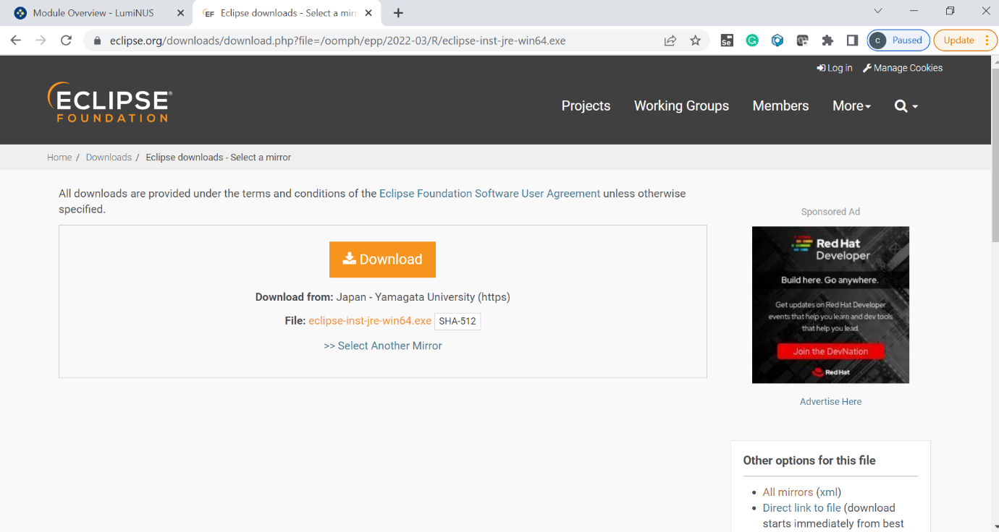
Save the file in C or D drive.
Select “Java for Developers” option to install the Eclipse.

Step 2: Include JUnit Library in your Java Project:
- Create a new Eclipse Java project called "JUnitTest".

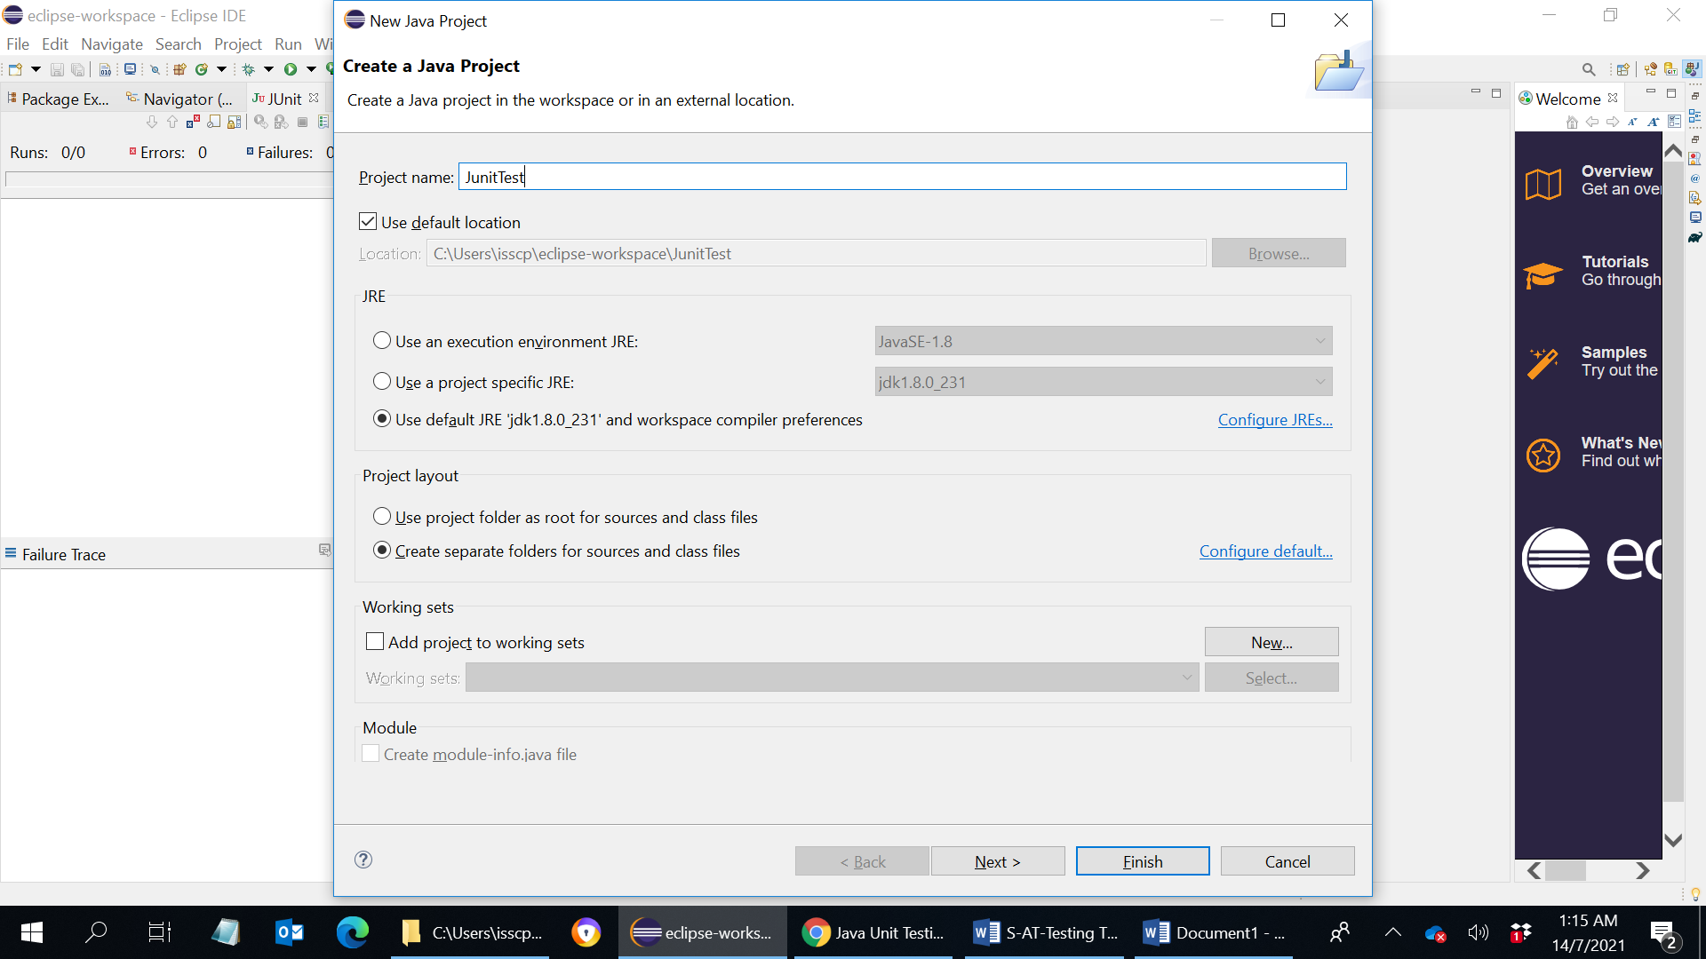

- Create a new class called "Calculator" under "src" folder, with the above program code.

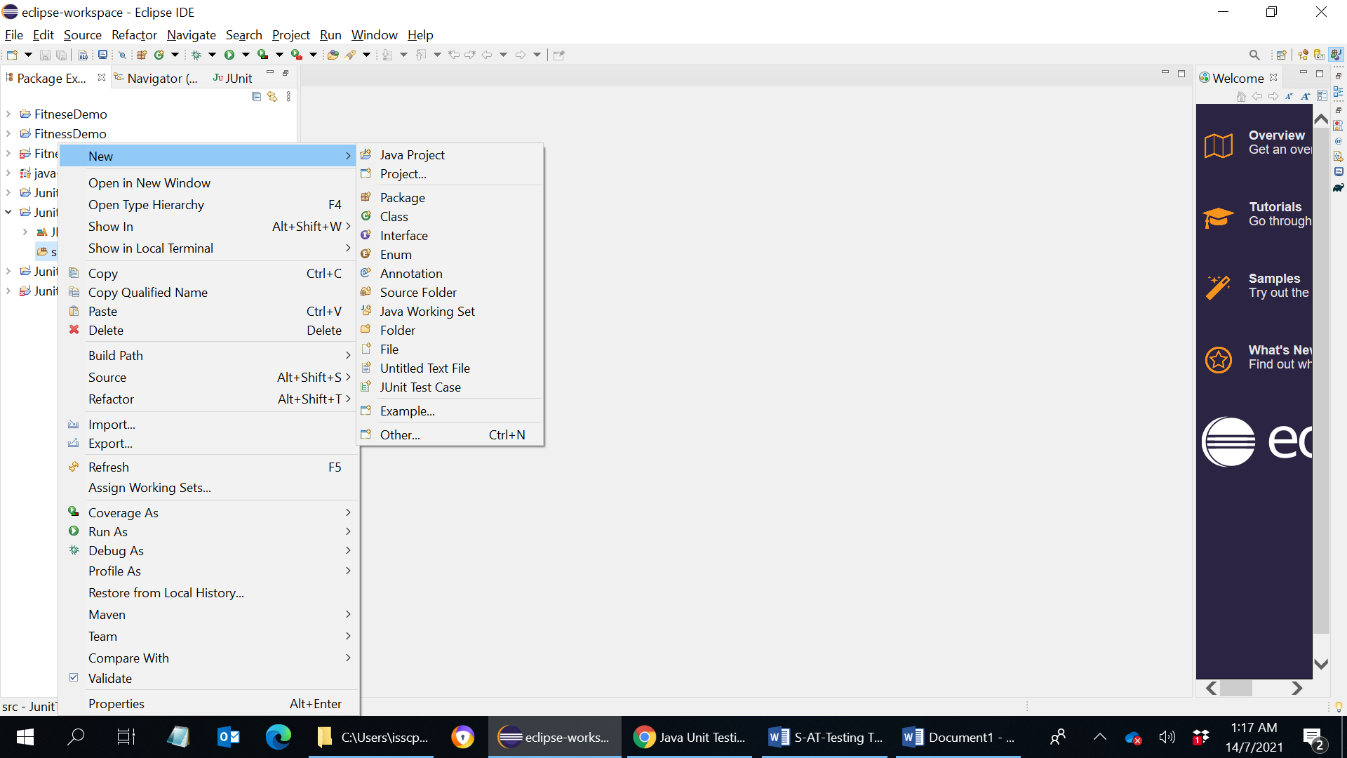

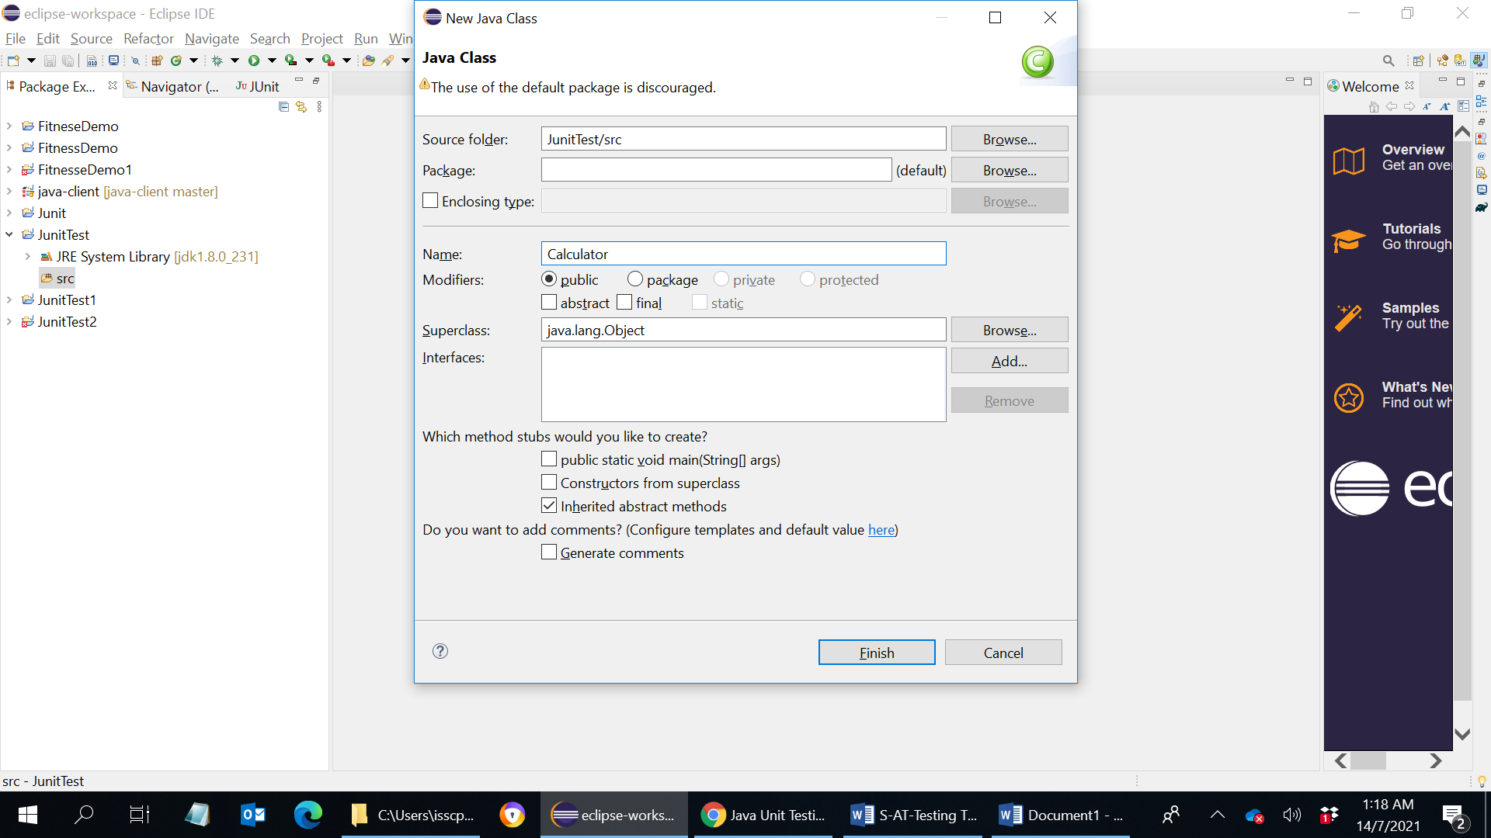

- Create a new folder called "test" for storing test scripts ⇒ Right-click on the project ⇒ New ⇒ Folder ⇒ In folder name, enter "test".


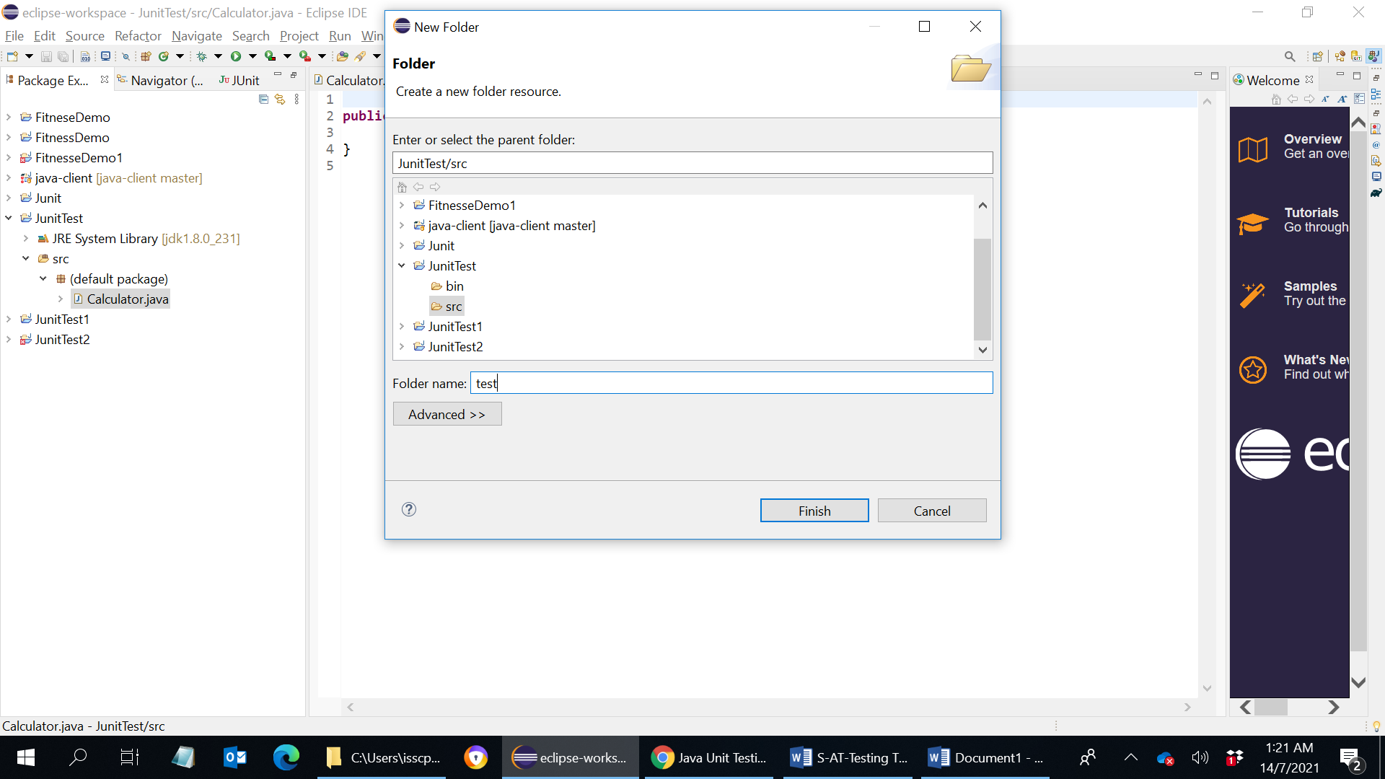

- Make "test" a source folder by right-click on "test" ⇒ Build Path ⇒ Use as source folder.

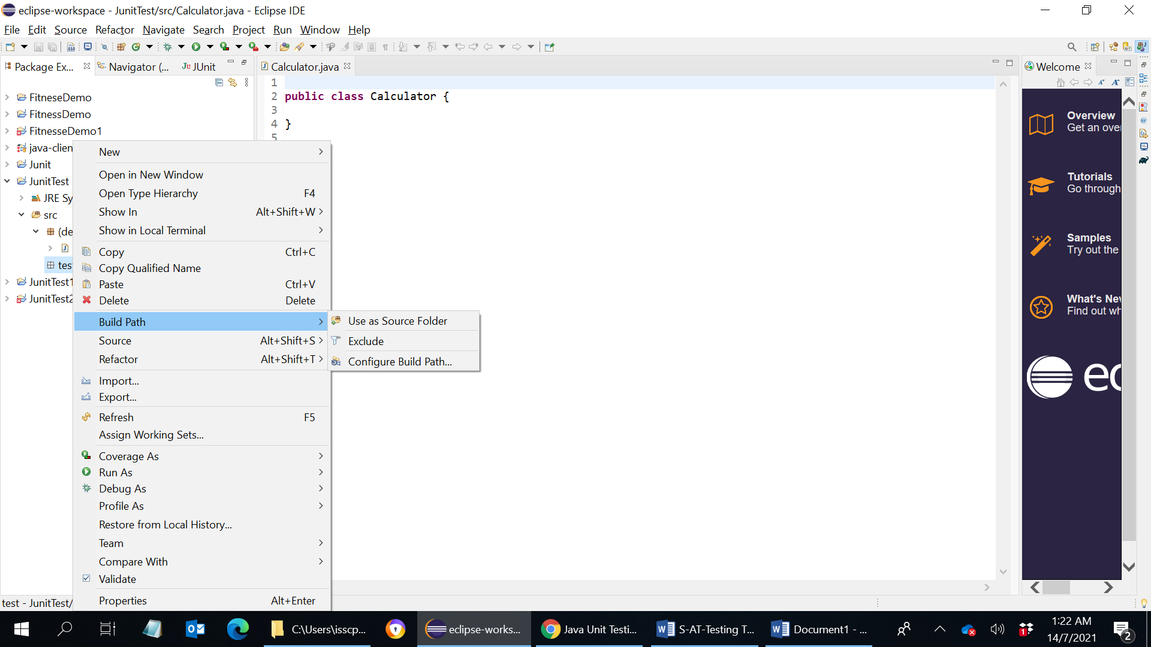

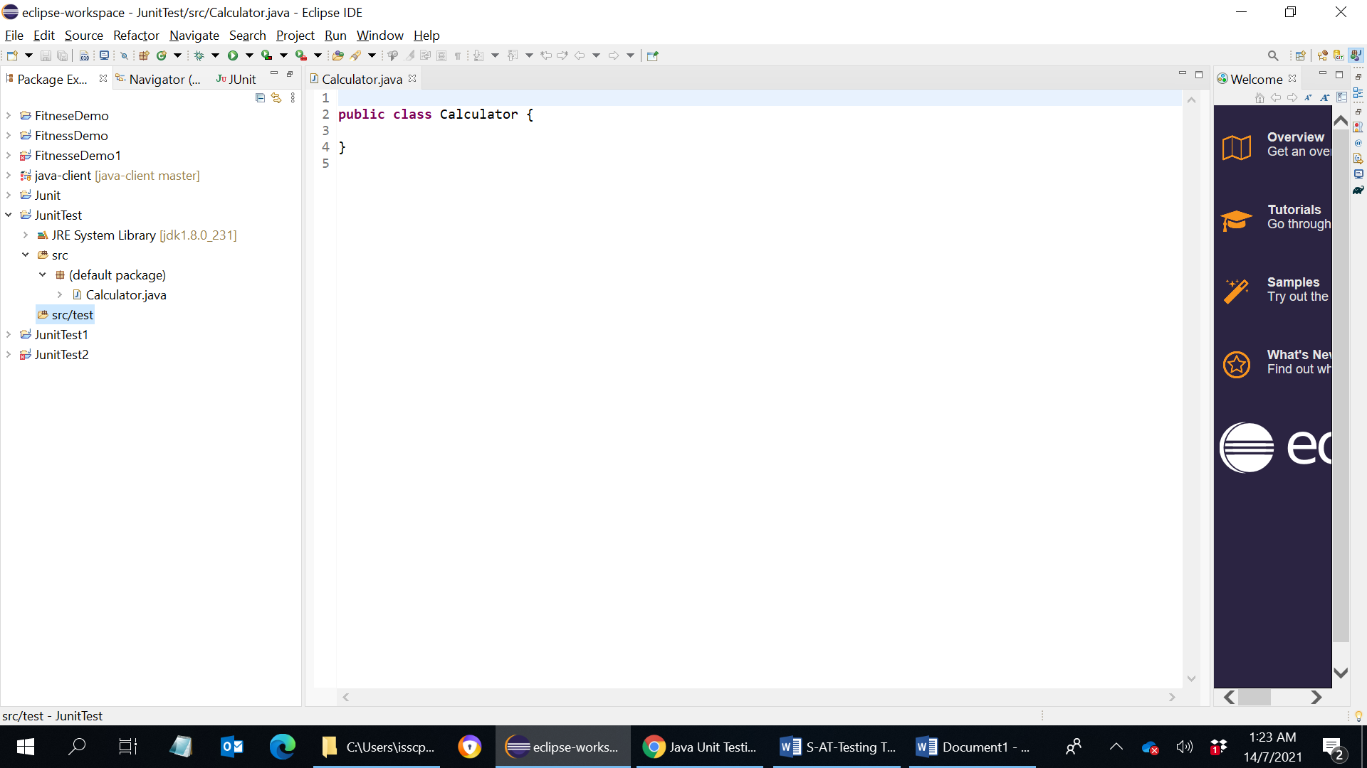

- Enter the following codes (to replace the above code):
  - we wish to carry out unit testing on the following Java program, which uses static methods to perform arithmetic operations on two integers. Take note that divide throws an IllegalArgumentException for divisor of zero.

/**
* The Calculator class provides static methods for
* arithmetic operations on two integers.
*/
public class Calculator {
public static int add(int number1, int number2) {
return number1 + number2;
}

public static int sub(int number1, int number2) {
return number1 - number2;
}

public static int mul(int number1, int number2) {
return number1 * number2;
}

// Integer divide. Return a truncated int.
public static int divInt(int number1, int number2) {
if (number2 == 0) {
throw new IllegalArgumentException("Cannot divide by 0!");
}
return number1 / number2;
}

// Real number divide. Return a double.
public static double divReal(int number1, int number2) {
if (number2 == 0) {
throw new IllegalArgumentException("Cannot divide by 0!");
}
return (double) number1 / number2;
}
}

- Create the first test case called "AddSubTest" ⇒ Right-click on folder "test" ⇒ New ⇒ Other ⇒ Java ⇒ JUnit ⇒ JUnit Test Case ⇒ New JUnit 4 test ⇒ In Name, enter "AddSubTest".

- 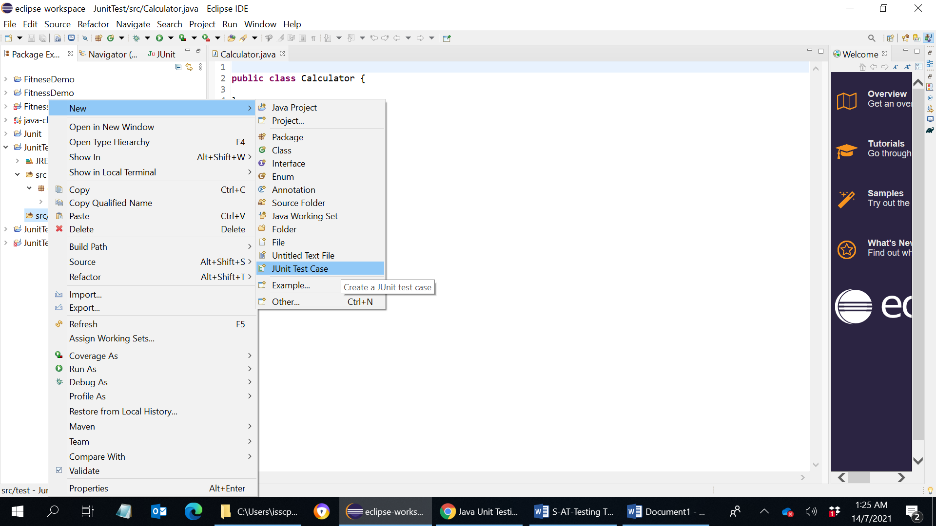

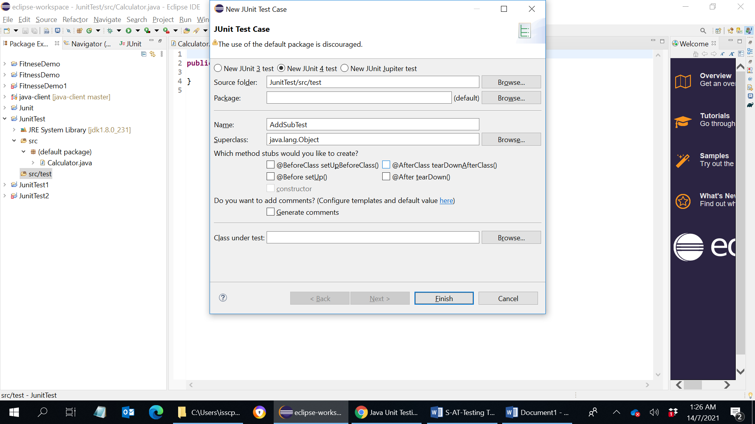

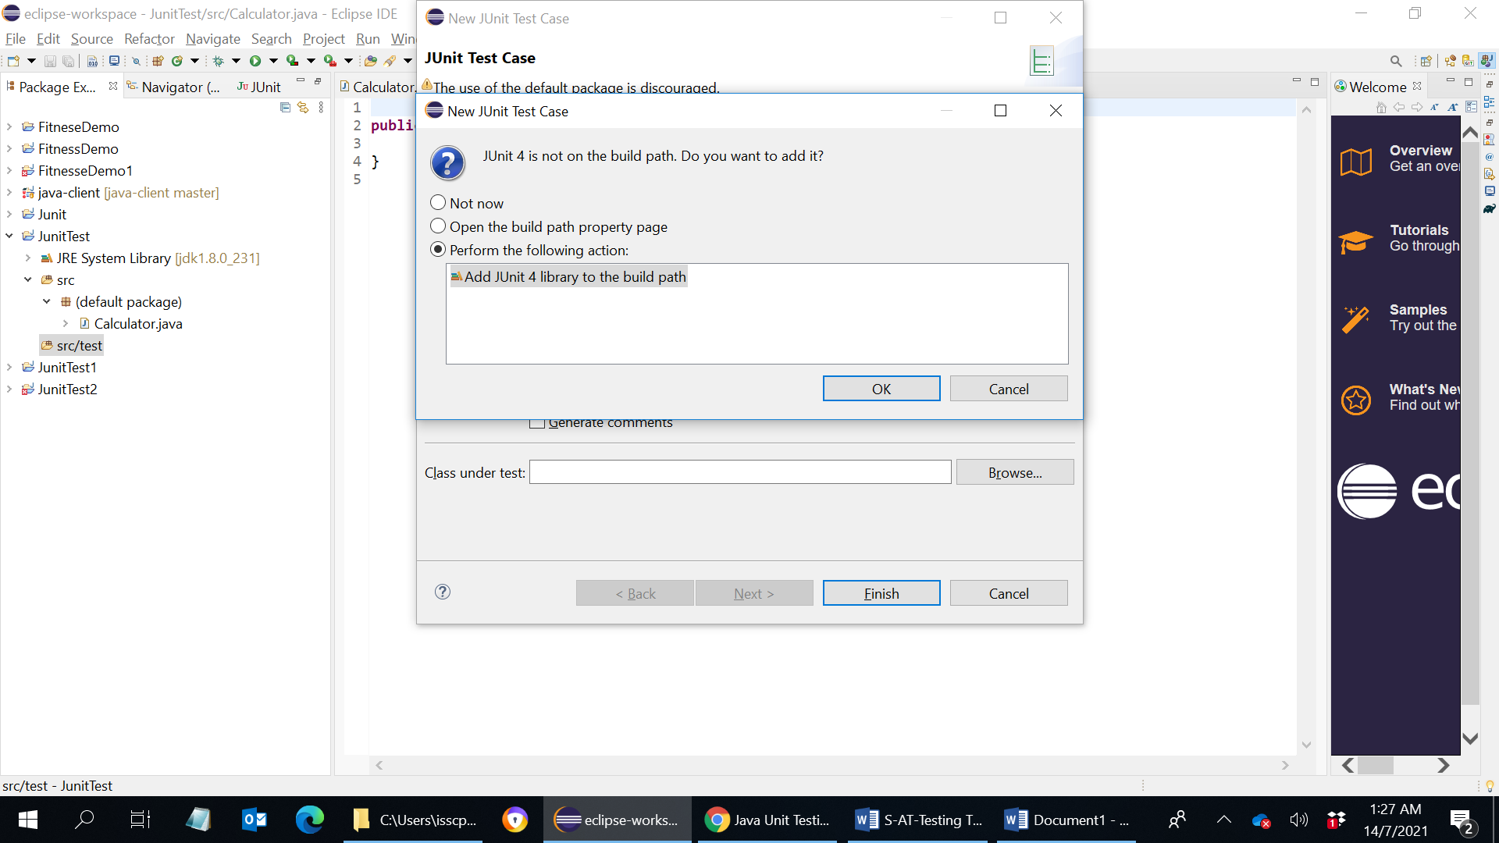

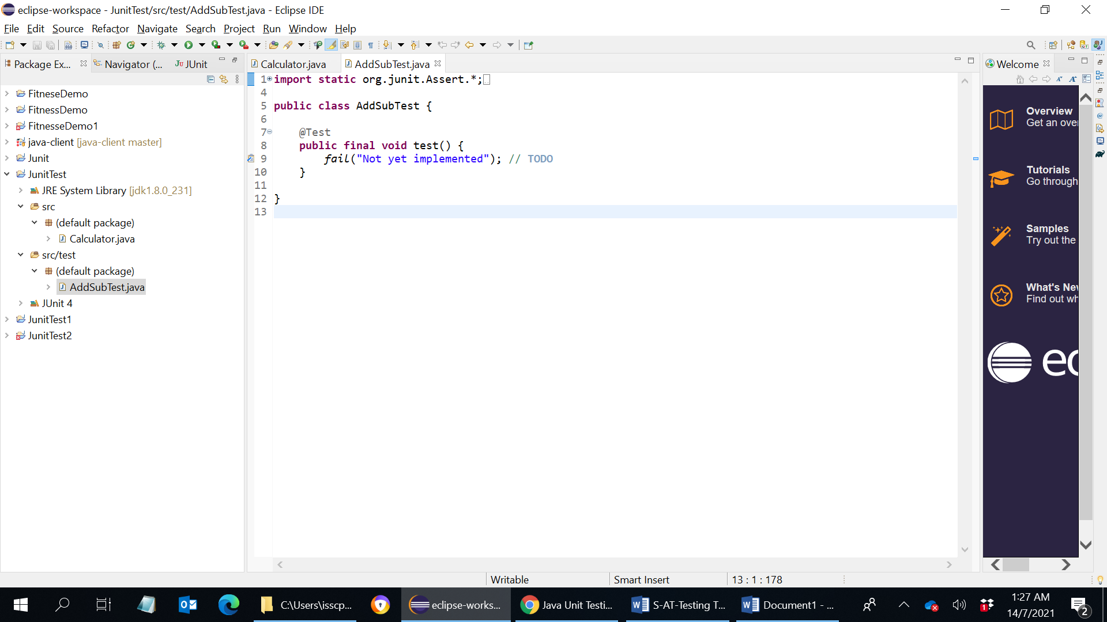

Enter the following codes (to replace the above code):

import static org.junit.Assert.*;
import org.junit.Test;

public class AddSubTest {
@Test
public void testAddPass() {
// assertEquals(String message, long expected, long actual)
assertEquals("error in add()", 3, Calculator.add(1, 2));
assertEquals("error in add()", -3, Calculator.add(-1, -2));
assertEquals("error in add()", 9, Calculator.add(9, 0));
}

@Test
public void testAddFail() {
// assertNotEquals(String message, long expected, long actual)
assertNotEquals("error in add()", 0, Calculator.add(1, 2));
}

@Test
public void testSubPass() {
assertEquals("error in sub()", 1, Calculator.sub(2, 1));
assertEquals("error in sub()", -1, Calculator.sub(-2, -1));
assertEquals("error in sub()", 0, Calculator.sub(2, 2));
}

@Test
public void testSubFail() {
assertNotEquals("error in sub()", 0, Calculator.sub(2, 1));
}
}

Step 3:
To run the test case, right-click on the file ⇒ Run as ⇒ JUnit Test. The test result is shown in the JUnit panel. 4 tests were run and Study the test results.

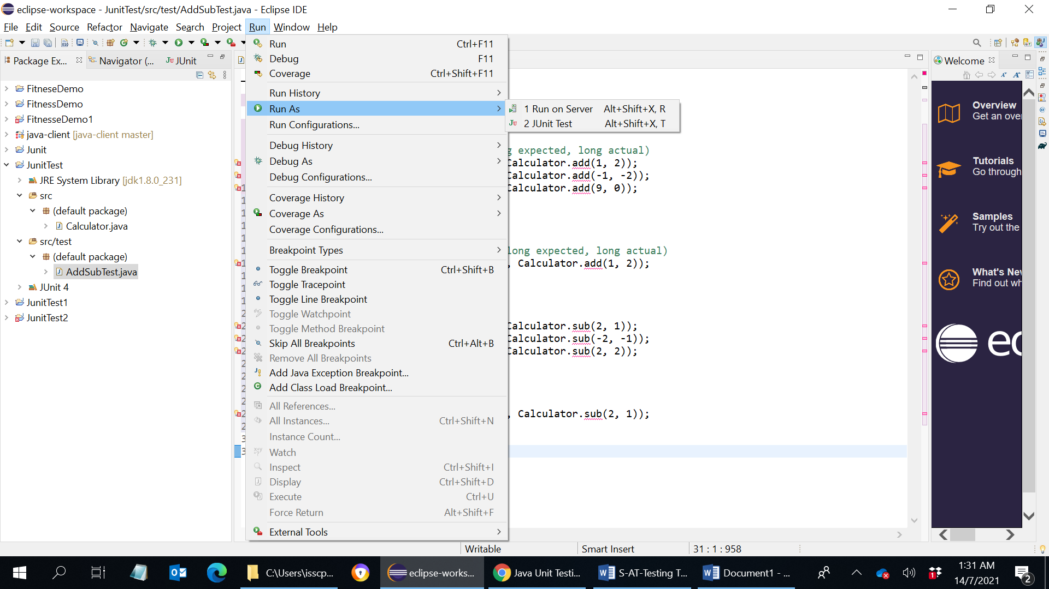

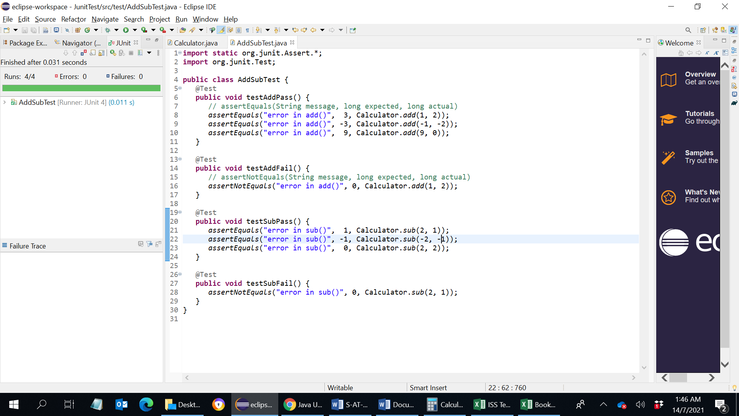
For test coverage, Try with different combinations for both positive and negative scenario and test data.
===========
For code path coverage % calculation:
- Install EclEmma plugin for eclipse – code coverage tool
- JaCoCo is a free code coverage library for Java, which has been created by the EclEmma

